**CISC 250**

**Assignment 2**

Transportation Layer Protocols

Network Layer Protocols

1. A host sends a TCP segment with source port number 80 and destination port number 49892.
   1. Is the host a server or a client? How can you tell? Explain the different types of port numbers.

**It is a server, because the source port number is permanent and the destination port number is dynamic.**

**Different types of port numbers:**

**1)well-known port numbers (0-1023): used by popular applications**

**2)Registered port numbers (1024-49152): used for less central applications**

**3)Ephemeral port numbers (49153-65535): assigned by the client kernel at**

**run time, can be reused.**

* 1. If the host is a server, what kind of server is it?

**It is an HTTP server (well-known port numbers)**

1. What is flow control? How does TCP handle flow control? For example, if a TCP segment from Host A to Host B contained bytes 15-39, the acknowledgement number from Host B acknowledging this segment is 40, and the Window Size field in this acknowledgement has a value of 50, then Host A may send through which byte?

**Flow control is the process of managing the rate of data transmission between two nodes to prevent a fast sender from outrunning a slow receiver. It provides a mechanism for the receiver to control the transmission speed, so that the receiving node is not overwhelmed with data from transmitting node.**

**TCP will set a window size, to make sure they have been received correctly based on a checksum or need to be resent.**

**Host A may send through 90 bytes.**

1. Write the following IP addresses in its binary form.
   1. 128.175.21.80

**10000000 10101111 00010101 01010000**

* 1. 255.255.255.192

**11111111 11111111 11111111 11000000**

* 1. 127.0.0.1

**01111111 00000000 00000000 00000001**

1. What is the subnet address if the destination address is 19.30.84.5 and the mask is 255.255.192.0? Show your calculation.

**Binary form of the mask:11111111 11111111 11000000 00000000**

**Binary form of the destination address: 00010011 00011110 01010100 00000101**

**So the subnet address is 19.30.64.0/18**

1. You have a Class C 192.168.10.0 /28 network. How many usable subnets and hosts do you have? Explain your answer (show your calculation steps).

**Class C have 24 bits for network, so the number of usable subnets should be 2^(28-24)=16**

**Then it leaves 32-28=4 bits for the hosts so the number of hosts should be 2^(32-28)-2=14**

1. How does a router make the routing decision based on the destination IP address and the routing table? Explain the routing algorithm with an example.

**First, for each row in the routing table, the router will take the destination IP address in packet and mask it with the mask in that row. After that, router will compare the result with the Network/Subnet value in that row. If the result matches, router will add the row to the list of matching rows for that packet. Otherwise, it will ignore that row.**

**Example:**

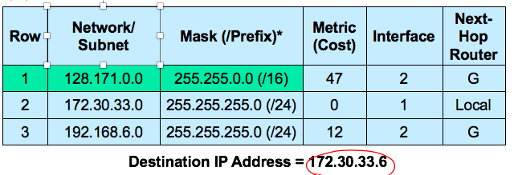

**the destination IP address is 172.30.33.6. Use the first row as an example. Since the mask is 225.225.0.0, the destination IP address after masking should be 172.30.0.0, then we compare the destination IP address after masking with Network/Subnet in that row, 172.30.0.0 is not equal to 128.171.0.0, so it’s not a potential route.**

**If there are multiple potential routes in a routing table, router will choose the more specific one. If there are several routes that are evenly specific, the router will depend on their metrics to make the decision (If metric is cost, then choose the one whose metric is the smallest. If metric is speed, then choose the one whose metric is the largest.)**